🔹 1️⃣ Traditional API Gateway
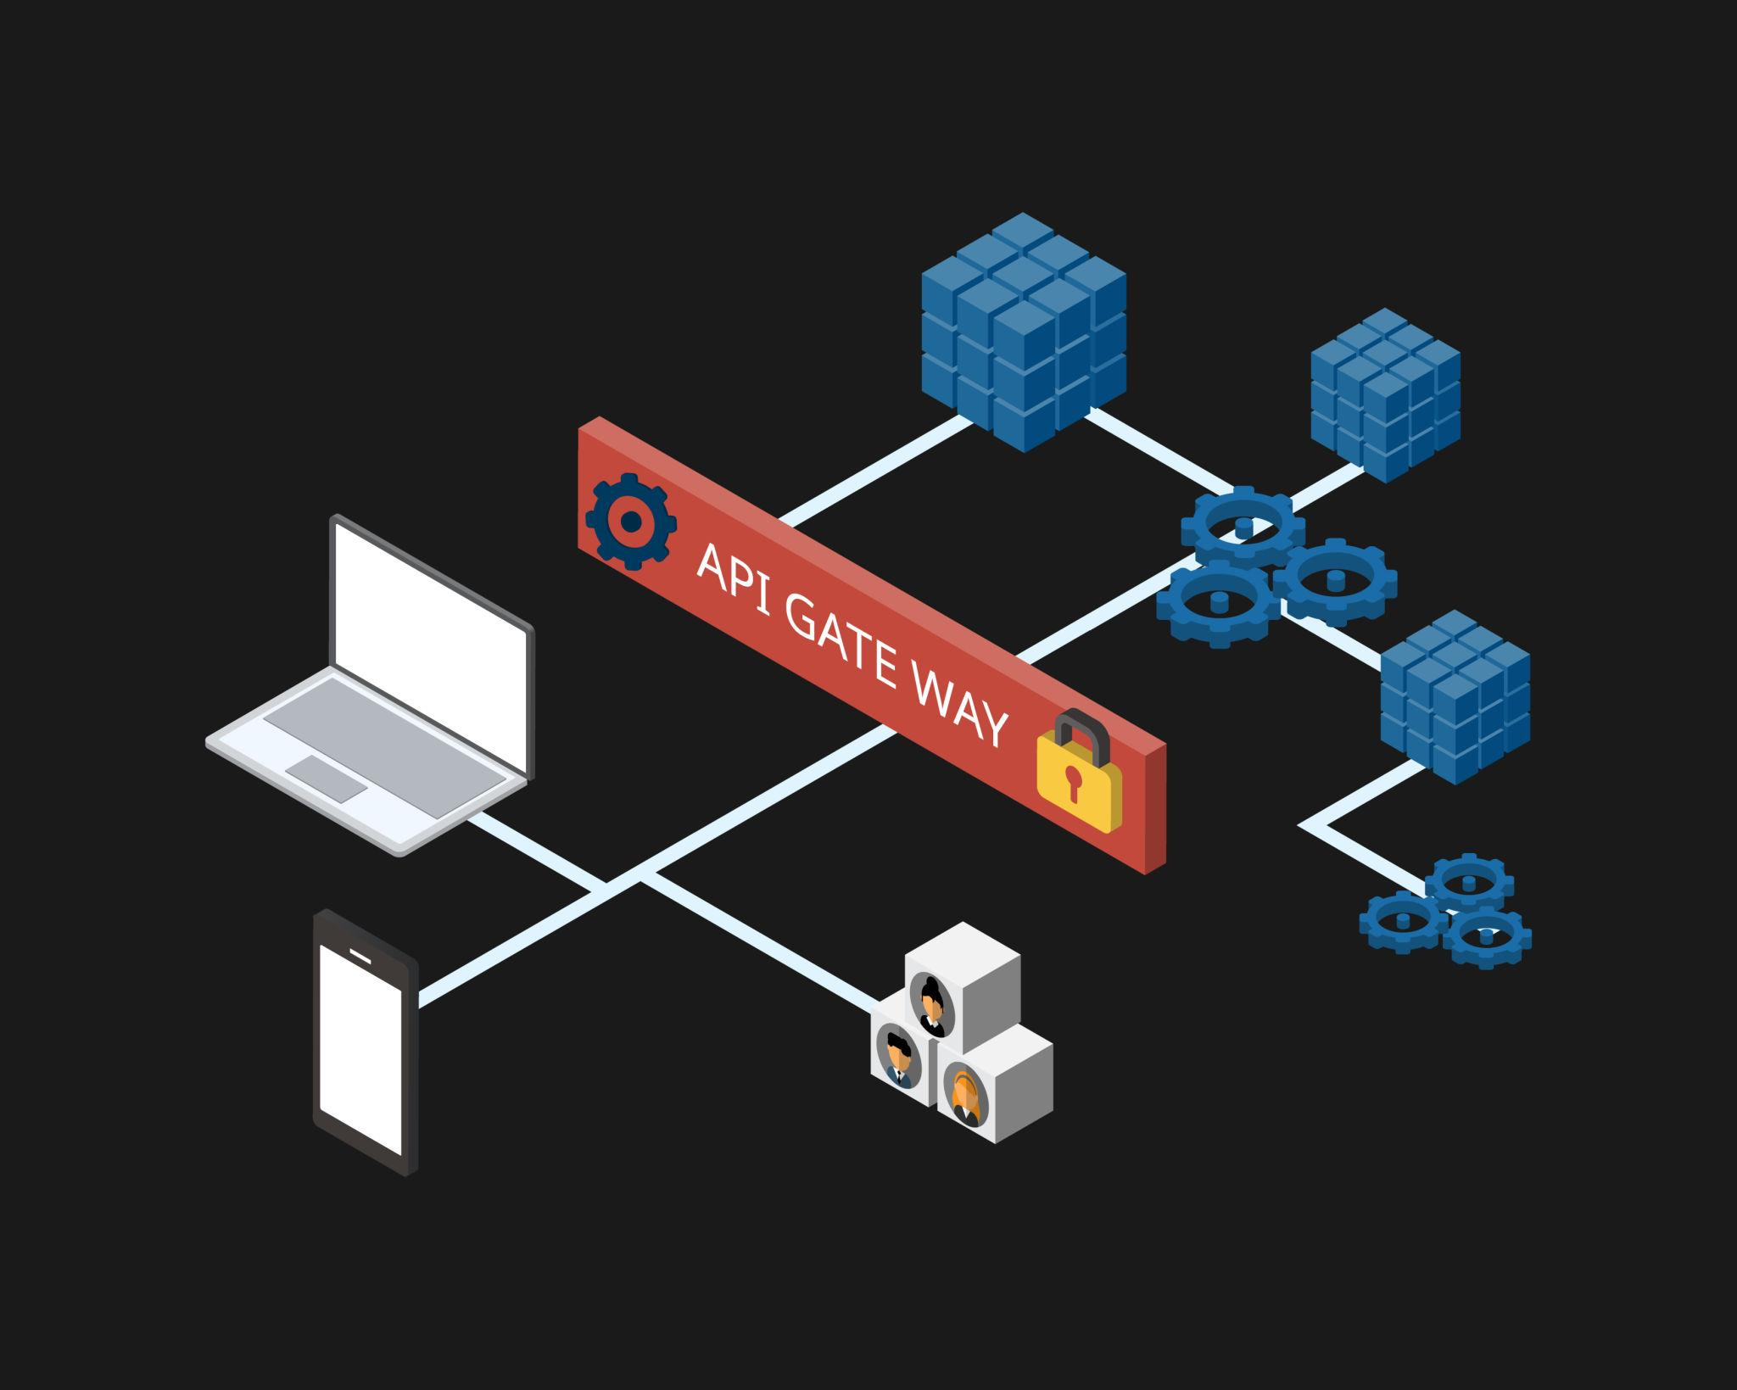
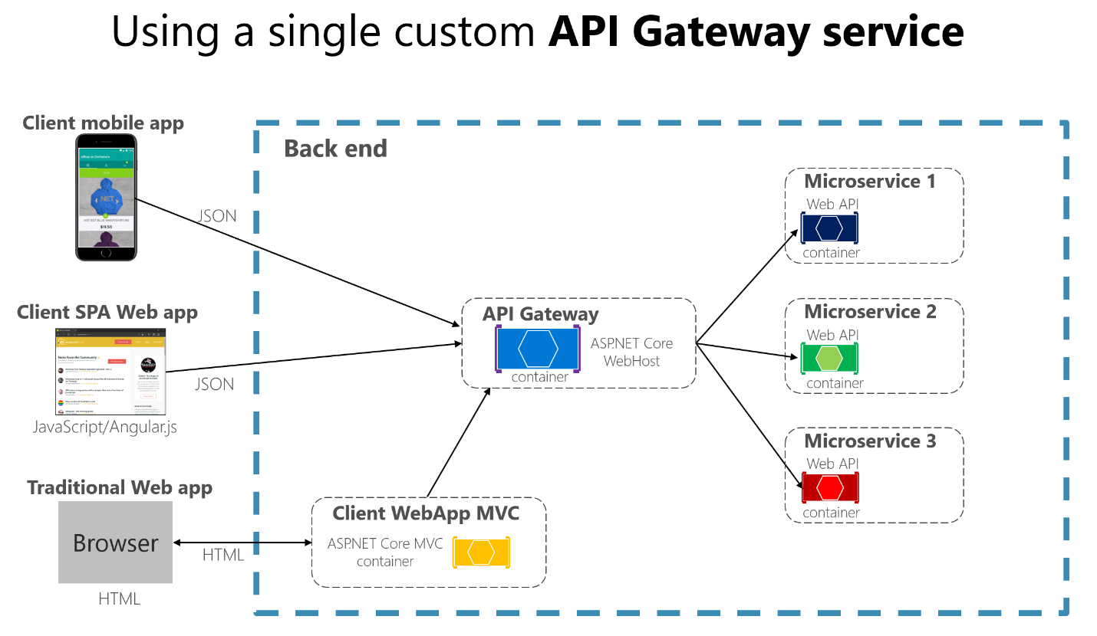
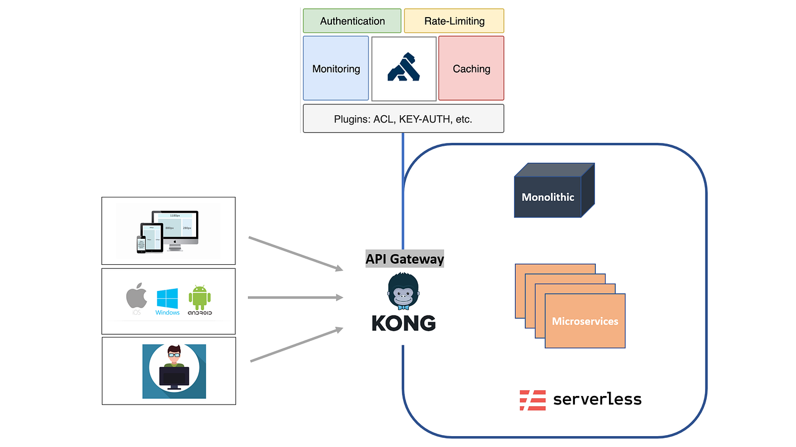
4
✅ What It Is
A traffic control layer that sits between clients and backend services.
✅ Primary Purpose
Manage, secure, and route HTTP/API requests to microservices.
✅ Core Responsibilities
- Authentication & Authorization (OAuth, JWT)
- Rate limiting / throttling
- Request routing
- Load balancing
- Logging & monitoring
- API versioning
- Transformation (REST ↔ SOAP, headers, etc.)
✅ Example Tools
- Kong
- Apigee
- AWS API Gateway
- Azure API Management
🧠 Mental Model
"Control and protect API traffic."
It manages network-level interactions between applications.

🔹 2️⃣ MCP Gateway (Model Context Protocol Gateway)
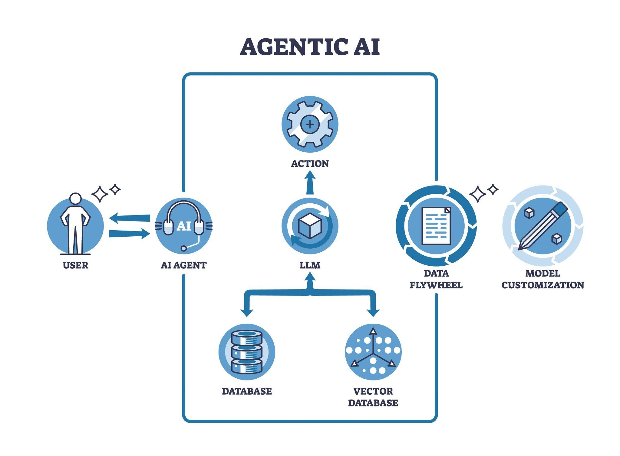
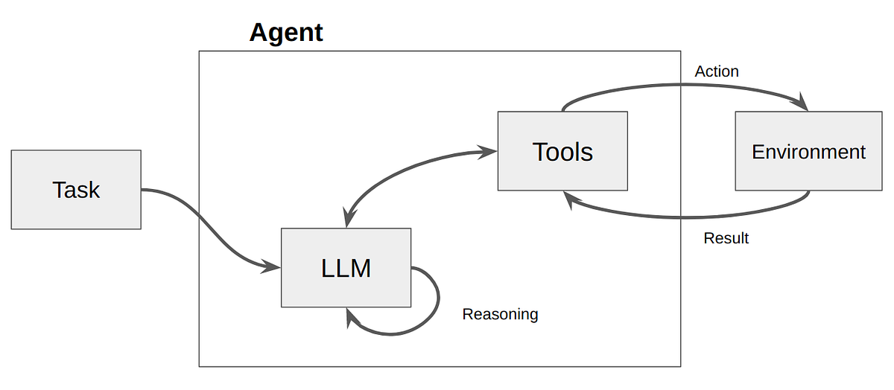
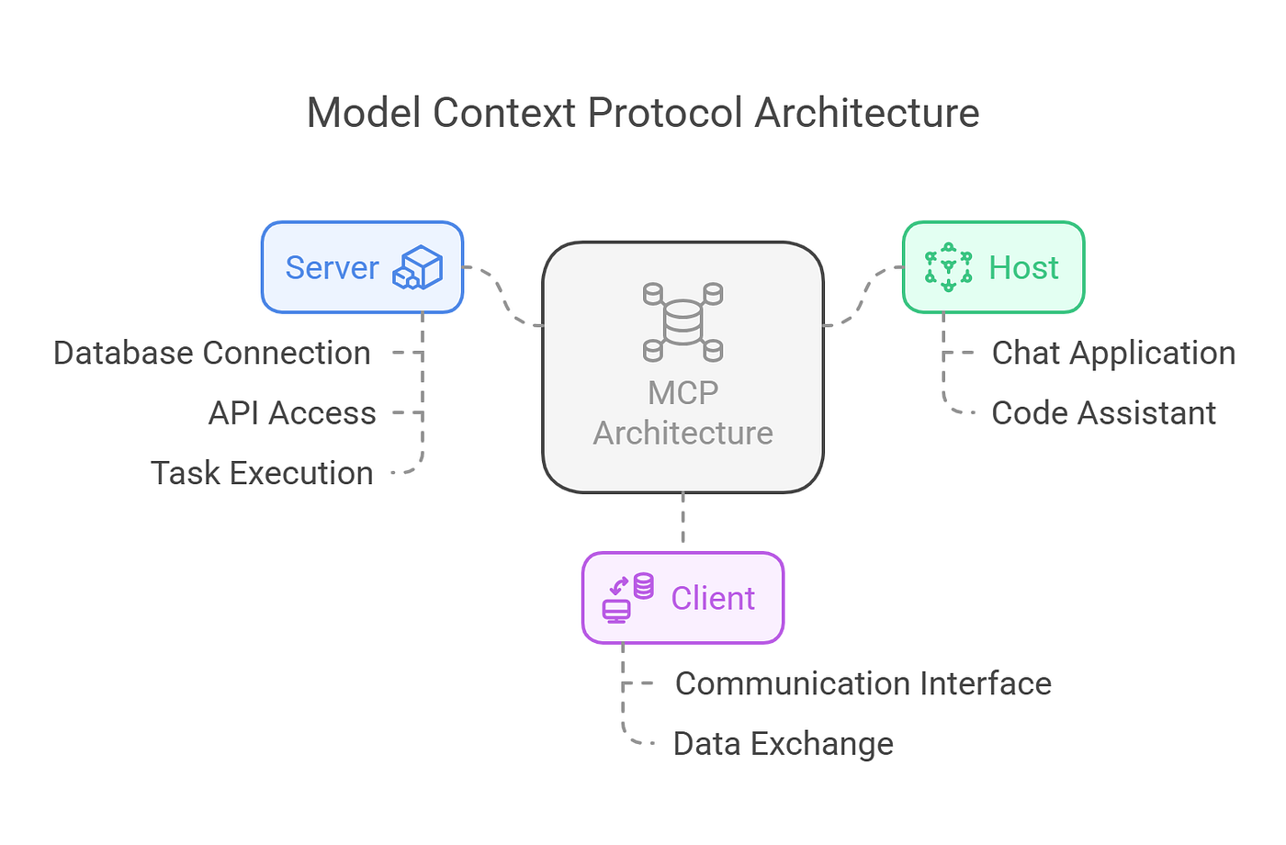
4
✅ What It Is
A context orchestration layer between AI agents (LLMs) and enterprise tools/data systems.
✅ Primary Purpose
Manage tool access, context flow, and agent permissions for LLM-based systems.
✅ Core Responsibilities
- Tool registration & discovery
- Structured tool calling
- Context injection
- Model access control
- Policy enforcement for agents
- Data scoping / segregation
- Auditing AI actions
- Multi-model routing
- Prompt governance
🧠 Mental Model
"Control and govern AI reasoning and tool usage."
It manages intelligence-level interactions, not just HTTP calls.

🔥 Side-by-Side Comparison
Dimension | Traditional API Gateway | MCP Gateway
Layer | Network / API Layer | AI / Reasoning Layer
Controls | Requests | Context + Tools
Audience | Apps & Services | AI Agents & LLMs
Security | Auth, throttling | Tool permissions, data boundaries
Routing | URL-based | Capability-based
Observability | API logs | Prompt, tool usage, reasoning audit
Awareness of AI | ❌ None | ✅ Fully AI-aware

🔍 Key Conceptual Difference
Traditional API Gateway:
- Stateless
- Request → Response
- Blind to business semantics
- Blind to AI reasoning
MCP Gateway:
- Context-aware
- Tool-aware
- Policy-driven
- Governs autonomous behavior

🚀 Simple Analogy
Traditional API Gateway | MCP Gateway
Airport security | Air traffic control for autonomous drones
Traffic cop | Mission commander
Guarding doors | Governing decisions

🏗 In Enterprise AI Architectures (Like Yours)
Traditional API Gateway:
- Protects your AI services externally
- Handles auth, throttling, network routing
MCP Gateway:
- Governs how agents access:
  - Internal APIs
  - Databases
  - File systems
  - SaaS tools
  - Vector stores
- Prevents data exfiltration
- Controls autonomy levels

🧠 One-Sentence Summary
A traditional API gateway controls who can call your APIs.
An MCP gateway controls what your AI is allowed to think with and act upon.

If you'd like, I can also:
- Draw a layered enterprise architecture showing both working together
- Map this to AI governance
- Or explain how this fits into a firmwide AI platform strategy
Give me good reasons why we as a firm should use MCP gateway something like Arcade or composio vs using tetrate or traditional API gateway.
Excellent — this is the right architectural debate to have.
Below is a firm-level justification framework you can use when explaining why an MCP Gateway (e.g., Arcade, Composio) is strategically different from — and often more appropriate than — relying solely on a traditional API gateway like Tetrate.

🔷 The Core Question
Are we governing API traffic — or governing AI behavior?
Traditional API gateways solve the first.
MCP gateways solve the second.

1️⃣ Traditional API Gateway (e.g., Tetrate)
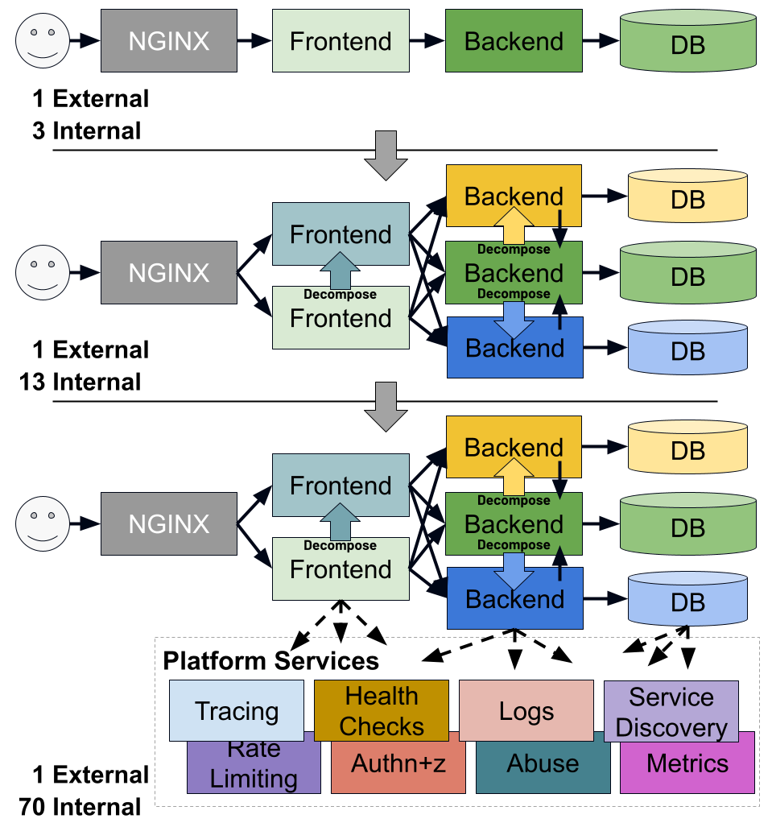

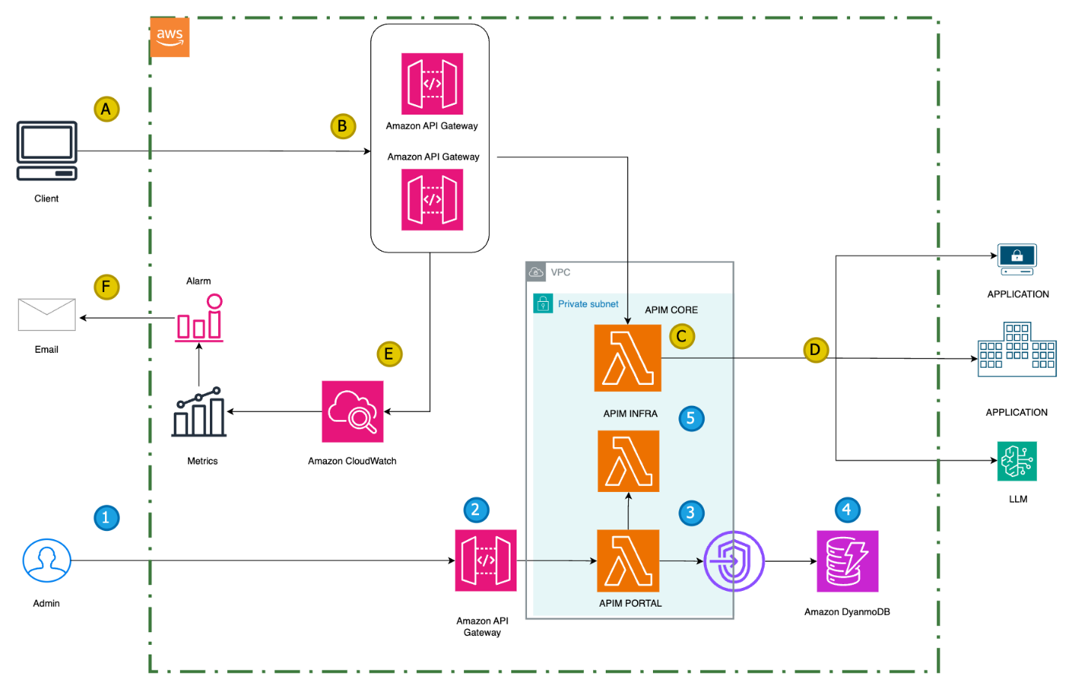
4
What Tetrate / Traditional API Gateways Do Well
- mTLS
- Service-to-service security
- Rate limiting
- Network observability
- Zero-trust enforcement
- Traffic routing
- North-south & east-west control
But They Are:
- Protocol aware
- Not reasoning aware
- Blind to LLM tool invocation semantics
- Blind to prompt context
- Blind to data sensitivity inside AI flows
They secure pipes, not decisions.

2️⃣ MCP Gateway (Arcade, Composio, etc.)

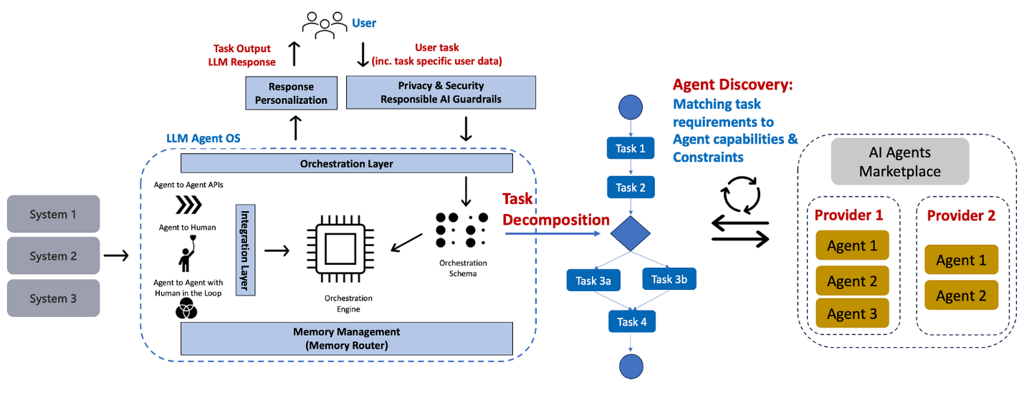
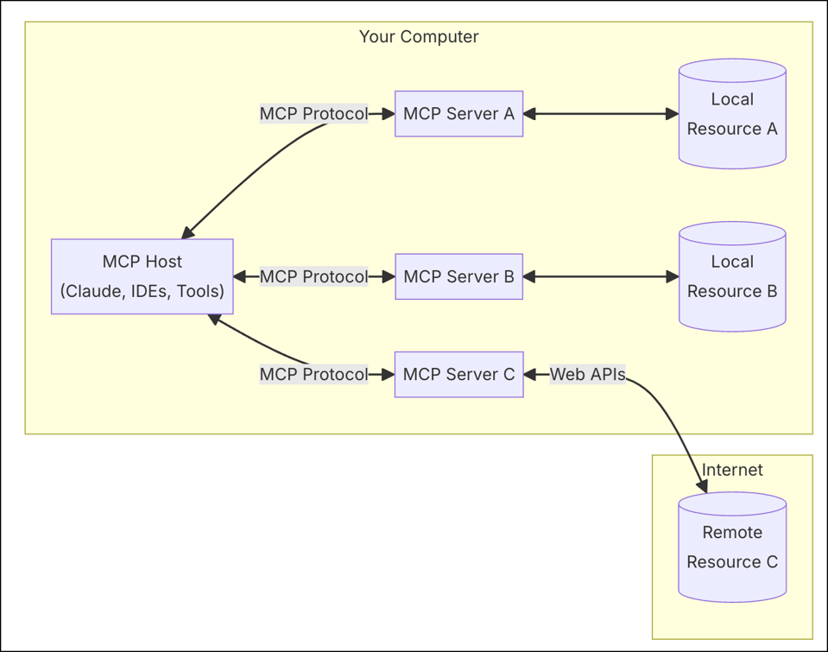
4
Examples:
- Arcade
- Composio
These platforms sit between:
- LLM / Agent frameworks
- Enterprise tools & APIs
- Internal systems
They govern AI-to-tool interaction, not just HTTP traffic.

🔥 Strategic Reasons to Use an MCP Gateway
Below are firm-level arguments you can use.

1️⃣ AI Needs Tool Governance — Not Just API Security
Traditional gateways:
“User X can call API Y.”
MCP gateways:
“Agent A can invoke tool B only under policy C with scoped data D.”
AI agents:
- Select tools autonomously
- Chain multiple calls
- Inject context dynamically
- Potentially exfiltrate data unintentionally
A traditional gateway has no concept of agent autonomy.

2️⃣ Fine-Grained Tool Permissions
MCP allows:
- Tool-level authorization
- Function-level access control
- Argument validation
- Data redaction policies
- Dynamic approval flows
Traditional gateways:
- Endpoint-level policies only
- No semantic understanding of function arguments
For example:
- "Transfer funds" tool
- AI tries to send $5M instead of $5K
Traditional gateway sees:
POST /transfer
MCP sees:
transfer(amount=5000000, account=external)
Huge difference.

3️⃣ Context-Level Data Segregation
In a regulated firm:
- Non-prod vs prod
- Business unit boundaries
- PII restrictions
- Insider data controls
MCP gateways can:
- Inject scoped context
- Restrict vector store access
- Mask fields before tool invocation
- Enforce policy based on reasoning chain
Traditional gateways cannot inspect prompt + model reasoning context.

4️⃣ Observability at the Intelligence Layer
Traditional observability:
- Latency
- 500 errors
- Throughput
MCP observability:
- Which tools were selected
- Why they were selected
- Prompt used
- Arguments passed
- Model reasoning chain
- Data sources accessed
For audit, model risk, and compliance — this is critical.

5️⃣ Alignment With AI Governance & Model Risk
Regulated firms require:
- Explainability
- Action traceability
- Controlled autonomy
- Human-in-the-loop enforcement
MCP gateways:
- Enable approval workflows
- Log decision chains
- Restrict high-risk tool calls
- Gate destructive actions
Traditional API gateways were never designed for AI decision governance.

6️⃣ Future-Proofing Agentic Systems
The firm will inevitably move toward:
- Multi-agent systems
- Autonomous workflows
- Tool chaining
- LLM-driven orchestration
Traditional API gateways:
- Assume deterministic clients
MCP gateways:
- Assume probabilistic reasoning agents
That’s a foundational difference.

⚖️ When Tetrate Alone Is Not Enough
Using only Tetrate means:
- AI agents look like any other microservice
- No semantic inspection of AI intent
- No policy based on reasoning
- No tool abstraction layer
- No agent-aware guardrails
You’d be retrofitting AI governance into infrastructure not designed for it.

🏛 Enterprise Framing for Leadership
You can position it like this:
Tetrate secures service traffic.
MCP secures autonomous intelligence.
Or:
API gateways protect our infrastructure.
MCP gateways protect our decision surface.

🧩 Architectural Positioning
Ideal enterprise setup:
External Client
↓
Traditional API Gateway (Tetrate)
↓
AI Gateway
↓
MCP Gateway (Tool Governance Layer)
↓
Enterprise Systems
They are complementary — not mutually exclusive.

🎯 Executive-Level Argument
- AI introduces non-deterministic behavior.
- Non-deterministic systems require semantic governance.
- Traditional gateways do not understand semantics.
- MCP provides semantic control over autonomous execution.
- Therefore, MCP is required for enterprise-grade agentic AI.

🔐 Risk Argument (Most Powerful)
Without MCP:
- AI can call tools in unexpected ways.
- Data leakage risk increases.
- Auditability gaps emerge.
- Regulatory exposure increases.
- Model risk teams will push back.
With MCP:
- Tool access is governed.
- Reasoning chain is observable.
- Data boundaries are enforceable.
- Autonomy levels are controllable.

🧠 One-Line Summary
Traditional API gateways secure traffic.
MCP gateways secure AI autonomy.

If you’d like, I can next:
- Convert this into a 2–3 slide executive-ready deck narrative
- Frame it specifically for a CISO audience
- Or tailor it to your firmwide AI platform strategy positioning**

What are the benefits of using MCP in a stateful and bi-directional way instead of designing MCP applications as stateless.
This is a sophisticated architectural question.
You’re really asking:
Why should MCP be stateful and bi-directional, instead of just a stateless tool proxy?
Let’s break it down clearly and at enterprise depth.

🔷 First: What Do We Mean?
🟢 Stateless MCP
- Each tool call is independent
- No session awareness
- No conversation memory
- No cross-call risk accumulation
- Pure request → validate → forward → return
🔵 Stateful + Bi-Directional MCP
- Maintains session context
- Tracks cumulative actions
- Can send signals back to agents
- Can dynamically adjust policy
- Can interrupt, escalate, or modify flows mid-execution
This becomes a control plane, not just a pass-through layer.

🔥 Benefits of Stateful MCP

1️⃣ Cumulative Risk Scoring
Stateless model:
- Evaluates each tool call in isolation
Stateful model:
- Evaluates risk across the entire session
Example:
Call 1: Query small dataset → low risk
Call 2: Query another dataset → low risk
Call 3: Combine datasets → medium risk
Call 4: External export → HIGH RISK
Individually harmless.
Collectively dangerous.
Stateful MCP can:
- Detect risk escalation patterns
- Trigger approval mid-session
- Block cumulative data exfiltration
This is impossible in a stateless design.

2️⃣ Cross-Step Policy Enforcement
In agentic workflows:
Step 1: Plan
Step 2: Retrieve data
Step 3: Transform
Step 4: Execute action
Stateless:
- Cannot validate consistency across steps
Stateful:
- Ensures plan matches execution
- Detects deviation from approved intent
- Prevents tool switching mid-flow
This prevents intent drift.

3️⃣ Dynamic Policy Adaptation
Stateful MCP can:
- Tighten permissions after suspicious behavior
- Reduce result sizes after threshold exceeded
- Disable certain tools mid-session
- Trigger higher monitoring levels
This is similar to adaptive authentication in cybersecurity.
Stateless systems cannot adapt based on session behavior.

4️⃣ True Bi-Directional Governance
Bi-directional means:
MCP doesn’t just receive calls —
It can influence agent behavior.
For example:
- Inject warnings
- Force re-planning
- Modify system prompt dynamically
- Request clarification
- Send “approval required” signals
This allows governance to actively shape reasoning.
Stateless MCP can only allow or deny.
Stateful MCP can guide.

5️⃣ Stronger Prompt Injection Defense
Prompt injection often unfolds across turns.
Example:
User plants malicious instruction gradually.
Stateful MCP can:
- Track suspicious patterns
- Detect context override attempts
- Recognize system prompt manipulation
- Identify abnormal tool selection
Stateless MCP sees only single calls.
Stateful sees behavioral trajectory.

6️⃣ Better Audit & Explainability
In regulated firms, auditors ask:
- What was the agent trying to do?
- How did the intent evolve?
- Was execution aligned to approved objective?
Stateful MCP can log:
- Session intent evolution
- Policy state transitions
- Risk score changes
- Tool selection reasoning chain
Stateless logging loses this narrative.

7️⃣ Support for Multi-Agent Systems
In multi-agent environments:
Planner Agent
Executor Agent
Validator Agent
Stateful MCP can:
- Track which agent initiated which action
- Enforce separation of duties
- Prevent cross-agent privilege escalation
- Ensure workflow boundaries
Stateless systems struggle here.

8️⃣ Governance of Long-Running Workflows
Think:
- Research agents
- Portfolio analysis agents
- Compliance review agents
- Enterprise workflow agents
These are not single-call systems.
They:
- Persist context
- Make iterative decisions
- Chain tools over time
Stateful MCP is required for proper governance.

🔄 Why Bi-Directional Matters
Most infrastructure today is:
Client → Gateway → Service
Bi-directional MCP enables:
Agent ↔ Governance ↔ Tools
This allows:
- Real-time intervention
- Escalation triggers
- Adaptive prompts
- Risk feedback loops
- Human escalation requests
It becomes supervisory, not passive.

⚖️ When Stateless MCP Is Enough
Stateless is fine if:
- AI is low autonomy
- Tool calls are simple
- No multi-step workflows
- Low-risk environment
- No regulatory pressure
- Minimal data sensitivity
Think: internal copilots with read-only access.

🏛 Enterprise Risk Framing
Stateless MCP:
- Secures calls.
Stateful + Bi-directional MCP:
- Governs behavior.
In regulated financial institutions, the second is often necessary.

🧠 Architectural Maturity View
Level 0: Direct API calls
Level 1: Stateless MCP (tool allow-list + validation)
Level 2: Stateful MCP (risk scoring + session awareness)
Level 3: Bi-directional MCP (adaptive governance + dynamic policy shaping)
Most enterprises aiming for serious agentic AI must reach Level 2 or 3.

🎯 Core Insight
AI risk is not isolated per request.
It accumulates over reasoning chains.
Only stateful systems can manage accumulated intelligence risk.

🧩 One-Sentence Executive Summary
Stateless MCP secures individual actions.
Stateful, bi-directional MCP governs evolving AI intent across time.

MCP Gateway: The Control Plane for Enterprise AI
As enterprises move from simple large-model calls to tool-using, stateful, autonomous agents, traditional API infrastructure and service networking solutions are no longer sufficient. An MCP (Model Context Protocol) Gateway acts as the centralized control plane for managing how agents access tools, data, policies, memory, and governance frameworks across the organization.
Where an API gateway standardized service-to-service communication in the cloud era, and service meshes orchestrated microservice networking, an MCP gateway standardizes agent-to-everything communication in the AI era — handling multi-turn reasoning, memory, tool invocation, and policy enforcement at the level of the agent’s decision process.

How MCP Gateways Compare to Legacy Infrastructure
Dimension | Traditional API Gateways (e.g., Apigee, Kong) | Service Mesh (e.g., Tetrate/Istio) | MCP Gateways (e.g., Arcade.dev, Composio)
Designed For | HTTP request routing & API management | Microservice network control | Agent orchestration & tool invocation
State Management | Stateless request/response | Service network state | Stateful multi-step agent workflows
Tool / Action Coordination | No | Limited to network policies | First-class tool execution, coordination and chaining
Reasoning & Reason Trace | No support | No support | Captures context & reasoning traces
Policy Enforcement | Static API policies (rate limit, auth) | Network-level RBAC, mesh policies | Semantic policy (safety, governance, data boundaries)
Memory & Context | N/A | N/A | Built-in context propagation, history, and memory
Cost & Efficiency | Optimizes API calls | Optimizes traffic | Optimizes model + tool usage holistically
Security Focus | API security | Network security | API security + data governance + inference controls
Lifecycle | Developer → API consumers | App mesh → infra | Agent lifecycle → tools, memory, governance

Why Legacy Tech Isn’t Enough for Agentic AI
🚧 API Gateways (Apigee, Kong)
API gateways are excellent at:
- Routing and versioning APIs
- Authentication, quotas, rate limiting
- Monitoring API traffic and SLAs
But they were not designed for AI reasoning, tool sequencing, or multi-step decision workflows. They treat calls as isolated HTTP transactions, not as agentic actions with state, context, and policy semantics.
In other words:
API gateways manage services; they don’t manage intelligence.

🕸️ Service Meshes (Istio, Tetrate)
Service meshes excel at:
- Fine-grained networking controls
- Mutual TLS & service-to-service security
- Traffic shaping (canary, retries, circuit breaking)
But they operate at the network layer, not at the semantic layer where agents live. They lack mechanisms for:
- Tool invocation logic
- Context and memory propagation
- Policy enforcement at the agent’s reasoning level
- Cost/risk governance for model invocations
Service mesh ensures secure microservice communication — but it does not enable agents to reason correctly across tools or enforce safety rules during reasoning and execution.

What MCP Gateways Bring That Others Don’t
🧠 Agent-First Orchestration
MCP gateways understand:
- Models
- Tools
- Context
- Memory
- Policies
This enables agents to plan, act, and refine across tools while logging and tracking reasoning steps.
📚 Context & Memory
Where API gateways forget state between requests, MCP gateways carry context across turns:
- Conversational history
- Shared state among chained tools
- Long-lived memories
This is essential for multi-step agents, not simple API calls.
🛡️ Semantic Policy Enforcement
MCP gateways embed policies that operate on:
- Data privacy
- Allowed tool sets
- Safety rules
- Cost governance
Rather than just network quotas or auth tokens, policies are enforced at the agent decision boundary.
🔄 Tool Invocation Coordination
Agents don’t just call tools — they:
- Choose which tool to call
- Pass structured arguments
- Handle retries, failures, fallbacks
- Validate and interpret responses
MCP gateways empower this workflow in a standardized, observable way.
📈 Observability for Reasoning
Traditional infra logs calls and latency; MCP gateways also log:
- Thoughts
- Plans
- Tool selection
- Execution paths
- Decision justification
This is critical for explainability, auditing, and compliance.

In Summary
API Gateways → optimized for service traffic management
Service Meshes → optimized for secure service networking
MCP Gateways → optimized for agentic AI orchestration and governance
In an era where:
- agents think
- tools act
- context persists
- policies govern
a gateway that only routes or networks services isn’t enough.
Enter the MCP Gateway — the control plane for the AI era.

